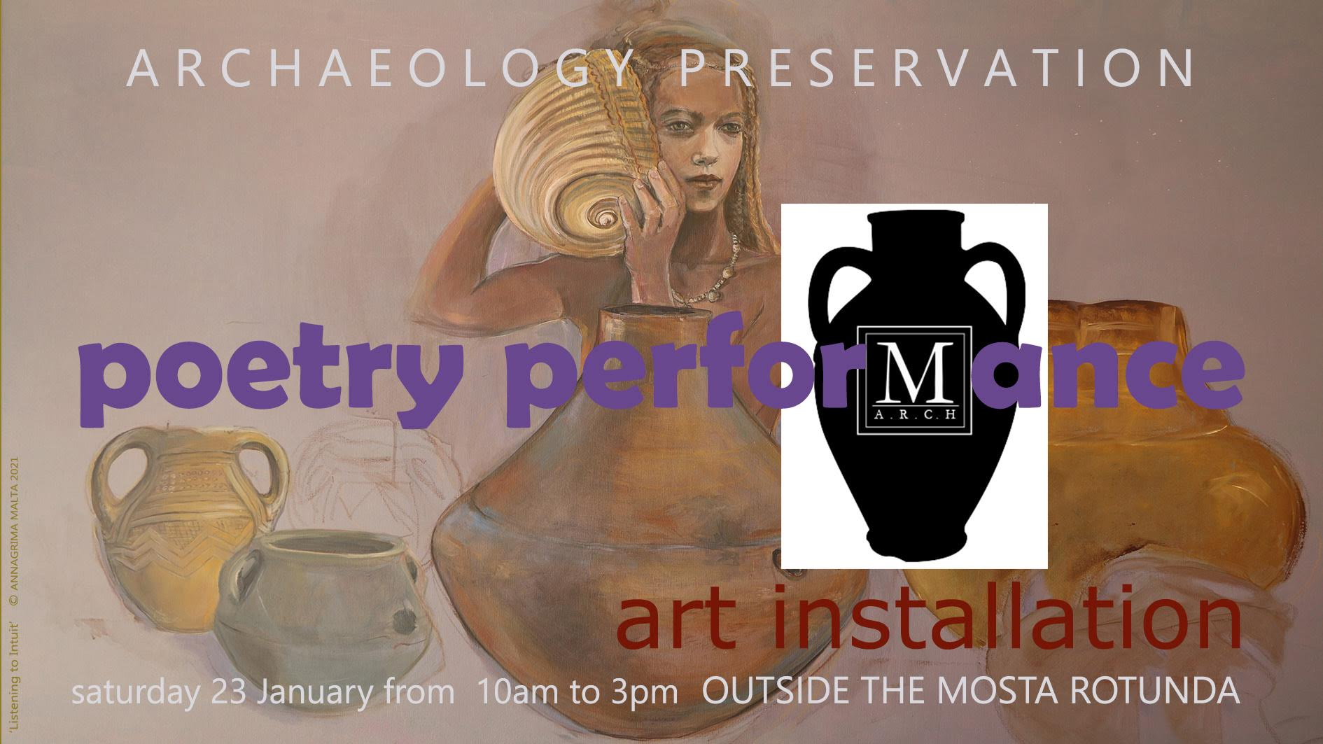
PROGRAMME
VISUAL ART INSTALLATION: Focusing on the theme of archaeology and its wonders: paintings, sculptures, and installations feature the art of Anna Grima, Alessio Cuschieri, Angele Galea, and Jamie Ciantar.
CHILDREN’S WORKSHOPS: Using origami, the ancient art of paper folding, Angele Galea will help children upcycle flyers, create origami animals and design archaeological motifs. Dawn Adrienne-Saliba will also lead archaeology related necklace-beading, colouring, writing and drawing activities.
SPOKEN WORD: Poetry and speeches related to Malta’s archaeology, Mosta’s tal-Qares site, and the necessity of protecting and preserving our heritage will be offered throughout the day. Performed by: Alessio Cuschieri, Andre Callus, Angele Galea, and Dawn Adrienne Saliba.
AUDIENCE FORUM: Visiting members of the public will be invited to express their views through speech, writing, and art.

Malta-ARCH is a collection of citizens who are deeply concerned about the preservation of Maltese archaeological sites and landscape.
The intention of this performance
and art installation
is to raise awareness
about the impending threat
to the tal-Qares
archaeological site
of Mosta, Malta
We at Malta-ARCH believe
that all should heed the Cultural Act of 2002:
Every person present in Malta shall have the duty of protecting the cultural heritage and the right to benefit from this heritage through learning and enjoyment. This cultural heritage is of irreplaceable spiritual, cultural, social and economic value. Its protection and promotion are indispensable for a balanced and complete life... Every generation shall have the duty to protect this heritage and to make it accessible for future generations and for all mankind.
To sign the petition
to save tal-Qares
please scan:
To learn more about the issue
please visit
www.Malta-Arch.com

Trading Archaeology & Civilisation for Shopping
by Dawn A. Saliba
I would like to begin with a quote from the Cultural Heritage Act of 2002, signed in Valletta: Every person present in Malta shall have the duty of protecting the cultural heritage and the right to benefit from this heritage through learning and enjoyment. This cultural heritage is of irreplaceable spiritual, cultural, social and economic value. Its protection and promotion are indispensable for a balanced and complete life... Every generation shall have the duty to protect this heritage and to make it accessible for future generations and for all mankind.
So why are we destroying thousands of years of prehistory?
To put up a supermarket next to LIDL? A warehouse? Flats?
Do the words of our laws mean nothing?
Does history, cultural identity mean nothing?
Tal-Qares, right here in Mosta, means something.
On this site, according to Malta Today, archaeologists discovered a three-chamber catacomb and four tombs. And there are also cart ruts and silo pits.
Nearby, there is an early Roman kiln—the only one of its kind in Malta, plus five ancient water cisterns and remnants of a Bronze Age civilization
And there is a proposal to turn this area into a supermarket?
60m away from LIDL?
Google Maps shows at least 16—16 supermarkets in Mosta.
Mosta is the supermarket capitol of Malta!
I’m from New York City, and for me it feels like Mosta is the supermarket capitol of the world!
Only powerful forces would have the audacity to erect a supermarket on top of a catacomb.
That is an action that desecrates the dead.
It annihilates our past. It obliterates our future.
And if I were among the dead whose graves they dared to desecrate,
I would rise up and face whatever developer or whichever politician who dared to lay waste to my bones and my home, to our ancestors’ and our great-great grandchildren’s birthright.
We know for a fact that this area was settled by the Bronze Age Civilisation, probably Phoenicians, and then later the Romans. There is \archival evidence pointing to probable occupation by the Temple Civilisation. We have a gorgeous 19th century watercolour of a megalithic wall from the very architect of this glorious dome in front of us, Giorgio Grognet de Vassé. E B Vella's 1930 Storja tal-Mosta also tells of megalithic remains. (Back then, it was known as “Wesgħa tal-Ġganti”, meaning the “Giant's Clearing”—but now, the only giant is Construction Companies.)
Today, there is one megalith left. One. Spray painted. Shoved into the middle of a rubble wall. Jammed in with nothing to indicate its meaning, its importance, humiliatingly shoved to the side of the new concrete walkway in between St Andrew’s Chapel and LIDL. And archaeological features such as postholes and possible cart-rut remains--probably stemming from Ancient Rome—were destroyed for this needless concrete path.
And let’s talk about St Andrew’s Chapel. This rare and precious, historic and beautiful building stemming from 1657, has already been damaged by the construction. There are cracks in its wall causing irreversible, structural damage. Mosta Archpriest Sebastijan Caruana himself asked AX Construction to acknowledge this harm. Others asked authorities to protect it, but, in their own words, 'no respect' was shown to the historic 17th century chapel: 'It was put aside and permits were issued by the PA'.
Tragically, this development also destroys nature. Where there was once garigue, butterflies, and an ancient landscape to roam in, two large buildings of flats were erected. And now, they are proposing uprooting 22 trees, including the protected indigenous Maltese Aleppo Pines, again, for what? A supermarket.
Is this the Malta that we want to leave to our unborn? A place filled with ugly, concrete buildings that fall down and kill people? A place choking on traffic and smoke that, yes, also kills people? This callous destruction of nature and culture steals something from every citizen in Mosta. It is a shortsighted disregard for our health and wellbeing. It provokes unnecessary feelings of hurt, outrage, helplessness and apathy.
This is not a fight we should be having. The site had been protected. In 2006, the Cultural Superintendent's Office designated Tal-Qares as an “Area of Archaeological Importance”. But in 2017, they changed its status to “low archaeological importance”. How is an area archaeologically important in 2006, but not one decade later? Why was this status changed? No one knows. But we all know that someone was making money. Today, this area is more akin to a rubbish heap than a site of cultural importance.
As moral, responsible citizens, we have a duty to protect and preserve that which is beautiful, that which is historic, that which brings us health and joy. This entire area, like so many areas should be, must be declared ODZ. And ODZ should mean something. The authorities are sworn to protect this site—They should do their duty. We must protect our past. We must preserve our heritage.
The advancement of knowledge is a sacred endeavor. It is the right of every Maltese Citizen to experience their archaeological past. Every child in Mosta should be able roam the fields and learn about their nature, culture, and history. This area, which has the remains of Bronze Age through Roman settlements, should be turned into a museum or a Cultural Heritage Centre, not a supermarket.
It is the obligation of the government and her citizens to protect this site. We need this area to be declared off-limits once and for all. When we destroy Malta—her nature, her history, her archaeology—it is irrevocably lost. Human civilization should not be destroyed for the sake of shopping.

tal-Qares by Michael Deguara
Ħudni ja missier fuq ix-xaghra tal-gganti  U tennili l-ħrafa tal-mara l-kbira  Li kielet il-ful u qiegħdet il-ħaġar f'imkienu.  Kellimni u għidli Nann x'tiftakar  Dwar dawn l-għelieqi ħa nagħlaq  Għajnejja u noħlom forsi  B'mara godlija li għomot il-fliegu  U għerqet għax qatgħulha idejha  Filwaqt li ħsibijieti jimirħu ma' raddet ir-roti  Bħax-xini li jimxi fl-art.  Fakkarni Nann fil-grajja ta' wlied il-ġganta -  Ta' bintha li saret omm l-Għawdxin  U binha li sar missierna.  Jintiseġ hawn is-sejjiegħ mal-ġebel kbir  Idur u jserrep mal-art tal-Qares  Bħal dura kbira mibnija  Min-nies ta' għerf bla miktub. | Father take me to the giants' moor  and tell me once more the tale of the great lady  who ate beans and placed the stones where they lie.  Grandfather speak to me and tell me what you remember  about these fields so I may close  my eyes and perhaps dream  of a strong woman who swam the channel  and drowned because her arms were cut off  while my thoughts wander along the cart ruts  like the boats that travelled on land.  Grandfather bring back to my mind the story of the giantess and her children -  her daughter who became the mother of the Gozitans  and her son who became our father.  The rubble walls and the large stones have been woven  together  as they turn and snake across the land of tal-Qares  like a large house built  by people of unwritten wisdom.

The following poems by Marlene Saliba were inspired by
Chris Micallef's painting, Religious Settlement:

Il-Misteru Jġelben  Il-Misteru jġelben.  il-Misteru jsawwab  ġo ramel it-talb  għall-baħar miftuħ,  fejn ħolm l-antenati  twaħħad ma’ tagħna.  L-għadam, l-imqades.  l-arti u l-għodod Neolitiċi  għadhom inebb ħuna.  minkejja sekli ta’kulturi varji  li ħakmuna u begħduna  minn nies li żergħu  f’dal-gżejjer it-tamiet ewlenija  mrawmin mill-arja,  mix-xemx, mix-xita  u l- ħamrija.  Il-misteru qiegħed  iċarċar f’demmna.  Wirt żerniq artna  aħna nqimuh.  Kburin, lill-barranin nuruh  u mill-vandali, il ħallelin u  l-qilla tal-elementi nkennuh.  Issa aħna wkoll  l-antenati tagħna--  ngħixu tamiethom fina.  waqt li nnisslu  fehmietna, u l-fidi  lill- ġenerazzjonijiet ġejjiena  ħerqana jistennew  il-miraklu tal- ħajja.  Il-misteru jibqa’ jġelben,  isawwab  ġo ramel it-talb  għall-baħar miftuħ,  fejn ħolm ulied uliedna,  kollu ħeġġa,  għad jitwaħħad ma’ tagħna. | The Mystery Flows  The mystery flows…  The mystery flows  along the sands of prayer  to the open sea  where all our ancestors’ dreams  have merged with ours.  As we still honour  the ancient bones, buildings  and art of those men,  women and children,  who planted in our isles  the first hopes nourished  by soil, air, sun, and rain--  as we loyally protect our legacy  from being pilfered and profaned  by thieves and vandals,  from being destroyed  by the toll of the elements--  the mystery flows on in our veins.  Yes, we are our ancestors now,  reliving their hopes,  and bequeathing  our blessings and aspirations  to new generations awaiting  the miraculous cycle of life.  The mystery flows…  The mystery flows  along the sands of prayer  to the open sea where  all our descendants’ dreams  will merge with ours…

The Giant’s Field by Catherine Camilleri

There is a place
not far from here,
that the giants once called home.

They dragged their stones
and stacked them into piles,
building a great wall to protect themselves
from the stinking reach of greed.

They dug holes
to store their food,
and tamed the unhospitable land,
culling it to their whim.

An age had passed in stillness.
People came from far distant lands,
and fished in the sea
and built settlements
and towns
and cities.

And the people brought
with them horses and goats,
pots of wine,
warships,
religion,
bombs,
cars,
and concrete.

And the people grew and grew,
consuming the land,
shearing the green foliage,
laying waste to the ancient trees,
choking the blue seas with sewage and trash.

And the people watched the carnage
from the windows unperturbed,
not knowing what to make of the stillness
between dust and smoke.

They did not yet understand
the inherent, unyielding
corruption of the fruit
from a poisonous tree.

My Dear by Angele Galea
Why am I here today?
Not with my family,
Not comfortable at home,
Not playing with my sons,
Not taking care of my needs and desires?

I feel compelled to let you know
What’s happening to you,
That’s why, my dear.

Your fathers and mothers left you a wealth
Someone else thinks they ought to destroy.
They want to take it away what’s yours
Make sure you and yours do not enjoy.

The profit is for them only.
They are not sharing.

Your wellbeing,
Your environment,
Your heritage,
Your village,
Your country,
Your world
Are not yours.

Your wealth is theirs,
Your environment is theirs,
Your memories are theirs,
Theirs to make more of and
Leave you being theirs as well, their customer.

“You enjoyed that for far too long, my dear.
We now want you to give up all that,
In the name of my profit, my gain and ravaging greed.”

“I will bulldozer eons of wealth
That had remained waiting for you for centuries,
Cover it in concrete,
Take your soul, money and heritage,
And leave you a child lost
In the middle of the busy, trafficky, polluted road, my dear”.

SUPERMARKETS
by Dawn Adrienne Saliba
SAVE.WISE.
ICELAND
PAMA
LIDL
Thousands of years of Maltese prehistory.
MAYPOLE
SHOPINN
BREMA
MIRACLE FOODS
An early Roman Kiln, Cart Ruts and Megalith.
ADAM’S FISH
CHEESE & CUTS
SAMMUT DAILY FRESH
A Punic catacomb, three ancient graves, Bronze Age remains.
MALTA FARMER MARKET WAREHOUSE
VILLAGE FRESH
CARLO’S MINI MARKET
THE CONVENIENCE SHOP
Garigue, Aleppo Pines, the 1657 St. Andrew’s Chapel.
NATURALI ORGANIC
WHENZHOU ASIAN SUPERMARKET
THE CONVENIENCE CORNER
COSTA TUTTO POCA.
COSTA TUTTO POCA.
Everything is cheap.
But not everything is priceless.

ARTISTS’ BIOGRAPHIES:
Alessio Cuschieri is an emerging artist who has a Bachelor’s of Fine Art from the University of Malta. Much of his oeuvre explores historical narratives as means of exploring contemporary social issues.
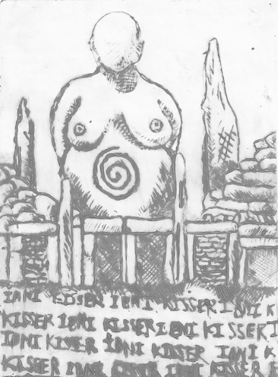
Andre Callus is an activist with Moviment Graffitti.
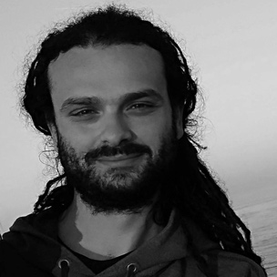 | As activists, we know from experience that people can and do make a difference. Right now, there is a feeling that things have become so bad, people really do have to try and change the system. When you imagine what Malta might be like in 20 years’ time, it’s frightening. A dystopia: a place where you can’t move about anymore. No open spaces anywhere. People have been feeling helpless for years, but now things have gone too far. Hopefully, people realise that they can get together and organise themselves to make a difference. It is an opportunity we have to grasp and build on.  There are many more battles to go.
Angele Galea is a creative practitioner in fine arts, music and drama. She is also the artistic director of More or Less Theatre, a company that specialises in educational and entertaining theatre productions for children.
You enjoyed that for far too long,
my dear.
We now want you to give up all that, in the name of
my profit
and my gain,
my dear.
Dawn Adrienne Saliba is a Maltese-American poet, playwright and theatre director who holds a Ph.D. in Drama from the State University of New York and an MFA in Theatre from New York University. She is a Senior Lecturer in English at MCAST and is also undertaking postgraduate studies in Archaeology at the University of Malta, where she is investigating performative liminality in the Hypogeum of Ħal Saflieni.
The advancement of knowledge is a sacred endeavor. Every child in Mosta should be able roam the fields and learn about their nature and past. When we destroy Malta—her nature, her history, her archaeology—it is irrevocably lost. Iż-Żejjed Kollu Żejjed
amidst the sands of time
she waits.
atop the stone wall
she climbs.
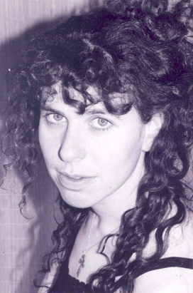
Marlene Saliba has published three books of poetry, as well as papers on peace and human rights education and on contemporary approaches to the teaching of literature. She has participated as a guest in international poetry gatherings and cultural events in England, France, Rhodes, Spain and the USA. Her bilingual poetry book, Xbihat tal-Antenati /Ancestral Visions (2011), focuses on the Neolithic temple people of the Maltese Islands. She holds a Master's Degree in English Literature from the University of Malta.
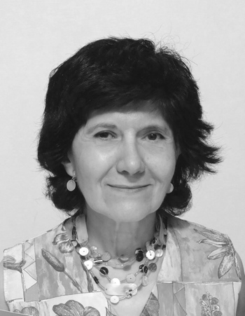 | In borrowed time,  an ancient vision waits  to be fired again to life  with the heat of a billion suns;  a billion dreams  that have returned  to greet the earth.
Michael Deguara is an anthropologist with a keen interest in prehistory and oral tradition. His first encounters with tal-Qares were childhood walks filled with wonder at the large stones that peppered the rubble walls.
The rubble walls and the large stones have been woven together
as they turn and snake across the land of tal-Qares
like a large house built
by people of unwritten wisdom
Anna Grima, MA (Melit) is an interdisciplinary artist living in Malta and Gozo. Her art practice includes figurative and abstract painting, illustration, creative writing and digital design. An interest in archaeology developed in 1999 after painting in the Ħal -Saflieni Hypogeum World Heritage site in Tarxien, Malta for the exhibition Seven Temples Seven Women at the National Museum of Archaeology.
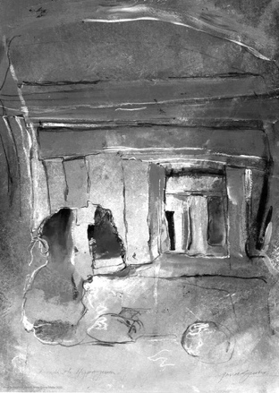
Catherine Camilleri is a published Maltese-American writer, poet and English language teacher from New York City. She has lived in Gozo for over a year and plans on pursuing a Master’s degree in English Literature.
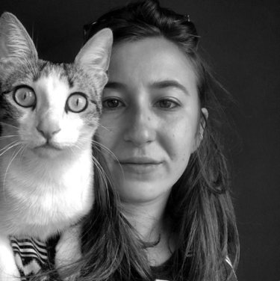 | Does Malta really need more buildings? Where is the line between creation and desecration? Is a supermarket really worth the eradication of Maltese heritage?  they watch the carnage  from the windows,  not knowing what to make of the stillness between dust and smoke
Jamie Ciantar is a BA product design student at MCAST’s Institute for the Creative Arts and hopes to work as a sustainable product designer in mainland Europe. Jamie utilizes mixed media including wood, clay, metal, and 3D materials.
